**Installation and Configuration of the device Ensemble**

The purpose of the document is to provide a quick start to configure the Tango Device Server to control Aerotech Ensemble drivers. You won’t find in this document any information on how to configure the Ensemble Drivers, please use the Aerotech documentation.

You can see on the photo 2 drivers, only one connected to the network, linked together with Aeronet.

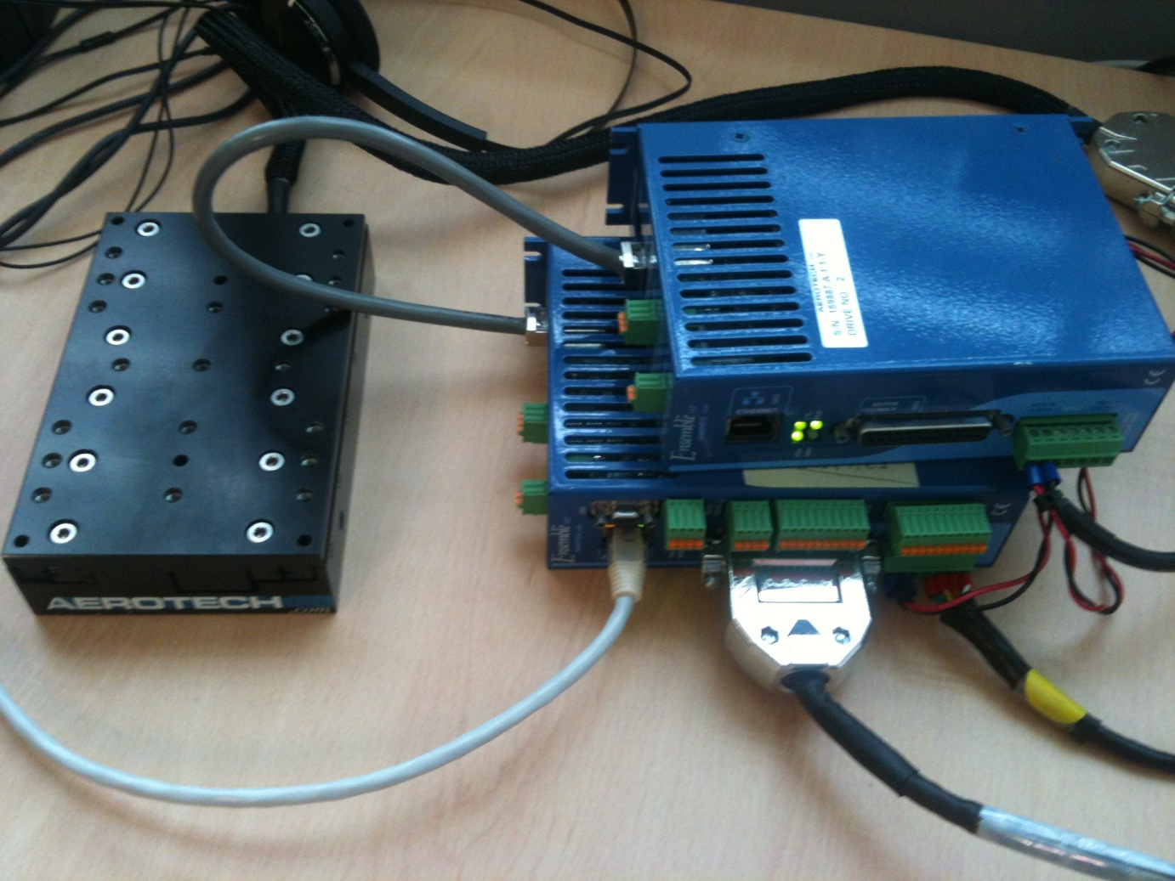The cEnsemble class has been written by

**Jean-Pierre Gaillet**  
JPG Micro-Services  
Ferme de Trousseau 91130 Ris-Orangis  
tel/fax : 01 69 77 11 12 portable: 06 89 77 27 37  
courriel : jpg.micro-services@laposte.net

The cEnsemble class can be used stand-alone, if you write your own code to interface to your control system. You will need to get YAT library from sourceforge (from http://tango-cs.svn.sourceforge.net/viewvc/tango-cs/share/yat/)

It has been wrapped in a Tango Device Server by Jean Coquet ([jean.coquet@synchrotron-soleil.fr](mailto:jean.coquet@synchrotron-soleil.fr))

You can report bugs on the device server using Tango bug tracker (<http://sourceforge.net/projects/tango-cs/>) specifying in subject “Aerotech Ensemble Device Server”

Ensemble drivers from Aerotech can control several motors from 1 driver, if they are linked together through Aeronet. They communicate with the control software through Ethernet TCP/IP.

The Tango Device Server contains 3 Tango classes :

* EnsembleBox handles the TCP/IP documentation and the global purposes commands.  
  For each Ensemble configuration you will have to set 1 Device Server in the Tango Database.
  + properties :
    - IP Adddress (Port is fixed to 8000)
  + attributes :
    - okCommandCounter
    - badCommandcounter
  + commands :
    - ExecLowLevelCmd let you send an Aerotech command to the controller
    - Reset : reset the drivers
    - SaveInFlash : save the changed parameters (mostly the soft limits) in the drivers
* EnsembleAxis is the simple user interface to control the axis. You add as much devices you have drivers connected (in the example, you will add 2 EnsembleUser devices)
  + properties :
    - AxisId : set here the axis name configured with Aerotech tools
    - AxisPositionRatio : the “user ratio” you want to apply to the position read/set (defaults to 1)
  + attributes :
    - position, R/W, the absolute position and setpoint
    - offset, R/W, the user offset added to the position
    - relativeMove, WO, incremental move
    - velocity, R/W, axis speed
  + commands :
    - BrakeOFF/BrakeON : controls the brake (even if there is no real brake)
    - Disable/Enable : enbles/disables the driver (equivalent to “ON/OFF”)
    - FaultAck : acknowledges faults, use it to go off when you reach the soft or hard limits
    - InitializeReferencePosition (sorry for that name…) allow you to Home  
      WARNING : you need an “asynchron homing” to perform that. See Jean-Pierre Gaillet for details on that.
    - Stop : stops with respect to deceleration.
* EnsembleExpert handles the “expert” usefull parameters
  + properties :
    - AxisId : set here the axis name configured with Aerotech tools
    - AxisPositionRatio : the “user ratio” you want to apply to the position read/set (defaults to 1)
  + attributes : have a look to the interface
  + commands : have a look at the interface.

Here is the Tango Devices inscription in the database :

Using the example as seen on the photo

1 Device Server contains 1 EnsembleBox Class and only one

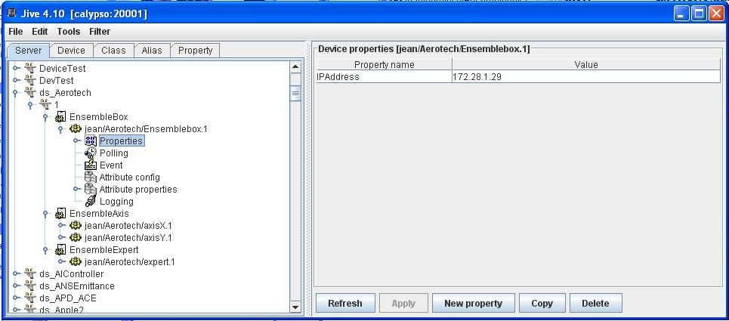

2 EnsembleUser devices, 1 for each axis:

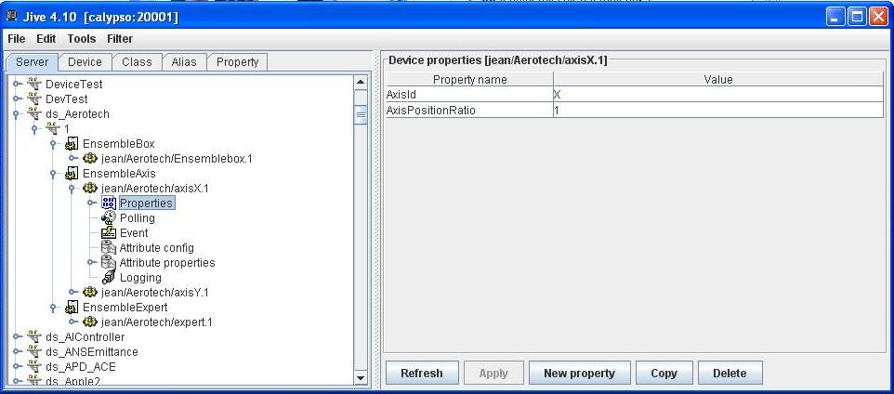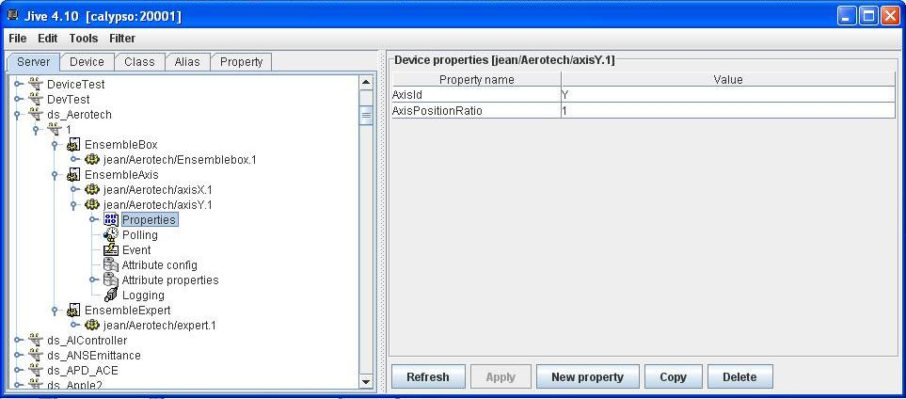

And finaly 1 EnsembleExpertfor the axis X, you could add 1 for the Y axis, or even not add them if you don’t need

